**UART- Universal Asynchronous Receiver Transmitter**

Let’s understand it word by word. Universal is okay. Asynchronous is means that whatever the communication may irrespective in between which it is held IT IS NOT RELATED TO TIME. In technical term it means that there is no clock signal shared with the main signal while the communication is held. Receiver Transmitter means that in this communication the message can be sent and received as well. It is a physical part of a circuit unlike SPI and I2C.

Applications:

* It is used when the command has to be received by the gps module like SM900.
* Used to connect the microcontroller with the PC.
* Peripherals that do not have an onboard UART can still use UART protocol for the connection to the PC

**SPI- Serial Peripheral Interface**

The good feature of this communication is that it can be used to connect to two microcontrollers. SPI provides full duplex communication i.e. it can do two way communications in which it can receive and transmit data simultaneously. Its major advantage over UART is that in UART you can only transmit a data of 8 bit at a time but in SPI you can transmit data over 8 bit at time.

Applications:

* Used to connect to various peripherals like sensor.
* Used in analog to digital convertors and digital to analog convertors.

**I2C- Inter Integrated Circuit**

It is communication which provides the facility of multiple “slave” which means that many peripherals can communicate with one master all simultaneously. It is again bidirectional.

<https://microcontrollerslab.com/i2c-bus-communication-protocol-tutorial-applications/#APPLICATION_OF_I2C_IN_MICROCONTROLLERS>

**Bluetooth module hc05:**

This is a simple code to switch on and off LED.

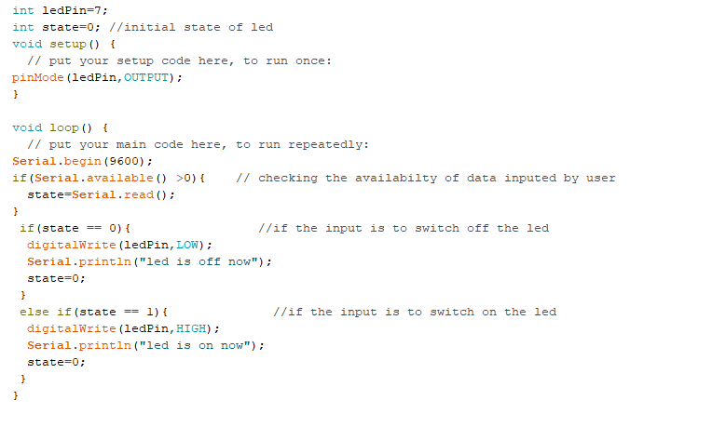

**PS2 controller**

Principle of working

The PS2 controller mainly has 9 lines that are to be controlled. Those are

1. **DATA:** This is the data line from Controller to PS2. This is an open collector output and requires a pull-up resistor (1 to 10k, maybe more). (A pull-up resistor is needed because the controller can only connect this line to ground; it can’t actually put voltage on the line).
2. **COMMAND:** This is the data line from PS2 to Controller.
3. **VIBRATION MOTOR POWER**
4. **GND:** Ground
5. **VCC:** VCC can vary from 5V down to 3V .
6. **ATT:** ATT is used to get the attention of the controller. This line must be pulled low before each group of bytes is sent / received, and then set high again afterwards. This pin consider as “Chip Select” or “Slave Select” line that is used to address different controllers on the same bus.
7. **CLK:**500kH/z, normally high on. The communication appears to be SPI bus.
8. **Not Connected**
9. **ACK:**Acknowledge signal from Controller to PS2. This normally high line drops low about 12us after each byte for half a clock cycle, but not after the last bit in a set. This is a [open collector output](http://en.wikipedia.org/wiki/Open_collector) and requires a pull-up resistor (1 to 10k, maybe more).